**Customer Lifetime Value Architecture**



**Project On:**

**Title : Customer Lifetime Value**

**By: Rushikesh Khandare**

**Contents**

## **1. Introduction.............................................................................................................................. 03**

**1.1 What is Architecture Design Document? ...................................................................... 03**

**1.2 Scope ................................................................................................................................. 03**

1. **Architecture............................................................................................................................... 04**

**2.1 Power BI Software Family................................................................................... 04**

# **2.2 Power BI Desktop Architecture.......................................................................... 04**

# **2.3 Explore the report building environment......................................................... 05**

**2.4 Key concept & Architecture....................................................................................... 06**

# **2.5 Create a visual..................................................................................................... 06**

**2.6 Create a dashboard...................................................................................................... 07**

**2.7 PowerBI Service………………………………………...................................................08**

## **3. Deployment...............................................................................................................................08**

**3.1 Login to the Power BI Pro service account..............................................................08**

**3.2 Publish dashboard on power BI service................................................................... 09**

**3.3 Publish dashboard with NovyPro...............................................................................10**

1. **Introduction** 
   1. **What is Architecture design document?**

Any software needs the architectural design to represents the design of software. IEEE defines architectural design as “the process of defining a collection of hardware and software components and their interfaces to establish the framework for the development of a computer system.” The software that is built for computer-based systems can exhibit one of these many architectures.

Each style will describe a system category that consists of:

* + - A set of components (eg: a database, computational modules) that will perform a function required by the system.
    - The set of connectors will help in coordination, communication, and cooperation between the components.
    - Conditions that how components can be integrated to form the system.
    - Semantic models that help the designer to understand the overall properties of the system.
  1. **Scope**

Architecture Design Document (ADD) is an architecture design process that follows a step-bystep refinement process. The process can be used for designing data structures, required software architecture, source code and ultimately, performance algorithms. Overall, the design principles may be defined during requirement analysis and then refined during architectural design work.

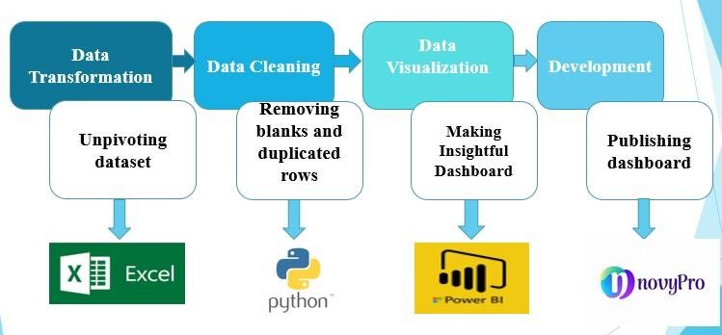

Fig1: Architecture of process and tools

3

**2. Architecture:**

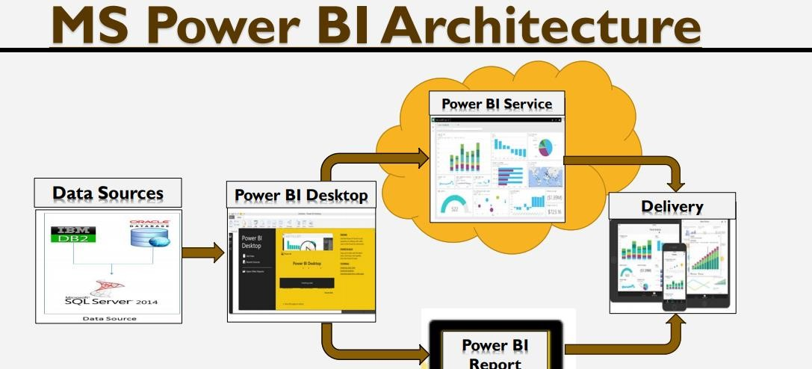

# Fig2: Architecture of Power BI

**2.1 Power BI Software Family**

1. Power BI(Desktop)
2. Power BI Pro (/Power Bi Premium)
3. Power Bi Service (Cloud)(SaaS)
4. Power BI Desktop for Reporting Server
5. Power BI Reporting Server (On Premises)

**2.2 Power BI Desktop Architecture**

**Business intelligence** (BI) is the set of techniques and tools for the transformation of raw data into meaningful and useful information for business analysis purposes.

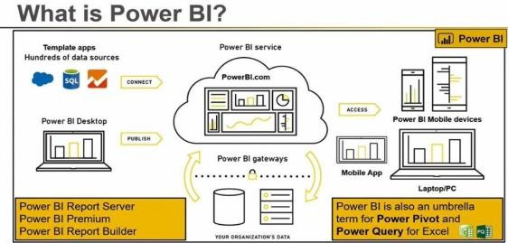

# Fig3: Architecture of Power BI Desktop 4

With Power BI Desktop, you can build advanced queries, models, and reports that visualize data. You can also build data models, create reports, and share your work by publishing to the Power BI service. Power BI Desktop is a free download.

**2.3 Explore the report building environment**

In Power BI Desktop, you'll begin to build reports in the Report view. You'll be working in five main areas:

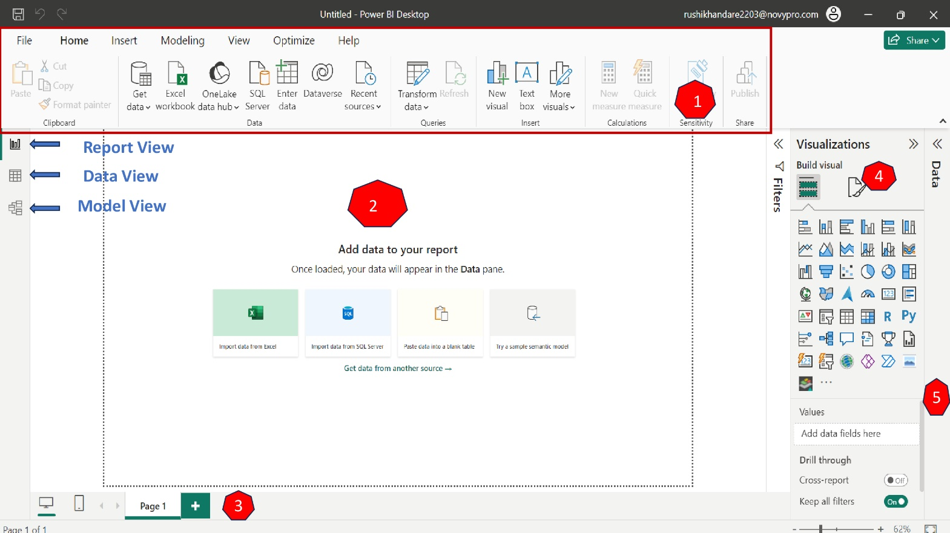

1. **Ribbon - Displays common tasks that are associated with reports and visualizations.**

1. **Report view**, **or canvas** - Where visualizations are created and arranged. You can switch between Report, Data, and Model views by selecting the icons in the left column.

1. **Pages tab** - Located along the bottom of the page, this area is where you would select or add a report page.

1. **Visualization pane** - Where you can change visualizations, customize colors or axes, apply filters, drag fields, and more.

1. **Fields pane** - Where query elements and filters can be dragged onto the Report view or dragged to the Filters area of the Visualizations pane, loaded dataset are available in this area.

## 5

**2.4 Key concept & Architecture:**

**BI solution architecture in the Centre of Excellence**

**BI solution architecture can consist of:**

1. **Data sources**: The Power BI Desktop makes discovering data easy. You can import data from a wide variety of data sources. After you connect to a data source, you can shape the data to match your analysis and reporting needs.

1. **Data ingestion:** Use **Power Query** to simplify data ingestion, transformation, integration, and enrichment.

1. **Big Data / Data preparation:**

* Data is stored in hundreds of internal locations of an organization, first we get excel workbook clean and prepared dataset.
* Clean and transform the data: Perform Exploratory data analysis with python and extract clean

dataset into csv format and load into power bi desktop for creating visuals and dashboard.

1. **Data warehouse:** Power BI allows you to directly connect to the data stored in your **Azure SQL Data Warehouse**, offering simple and dynamic exploration

1. **BI semantic models:** BI semantic models **represent a semantic layer over enterprise models**. They're built and maintained by BI developers and business users. BI developers create core BI semantic models that source data from enterprise models.

1. **Reports:** The Power BI Desktop includes the Report View. Select the fields you want, add filters, choose from dozens of visualizations, format your reports with custom colors, gradients and several other options. The Report View gives you the same great report and visualizations tools just like when creating a report on PowerBI.com.

• Save your reports With the Power BI Desktop, you can save your work as a Power BI Desktop file. Power BI Desktop files have a .pbix extension.

**2.5 Create a visual**

To create a visual, drag a field from the Fields list onto the Report view click on get data, select which types of data we want to upload.

In this project we are going to upload our clean dataset get from Python Exploratory data analysing i.e.

final Customer Lifetime Value.csv.

6

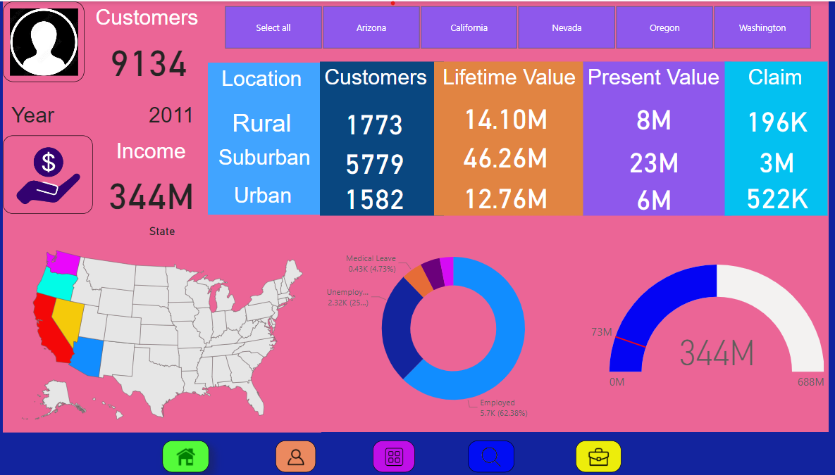

**2.6 Create Dashboard:**

You can only create a dashboard from Power BI Service (the online version). You can’t make or see a dashboard on Power BI Desktop. On mobile, you can only view and share dashboards.

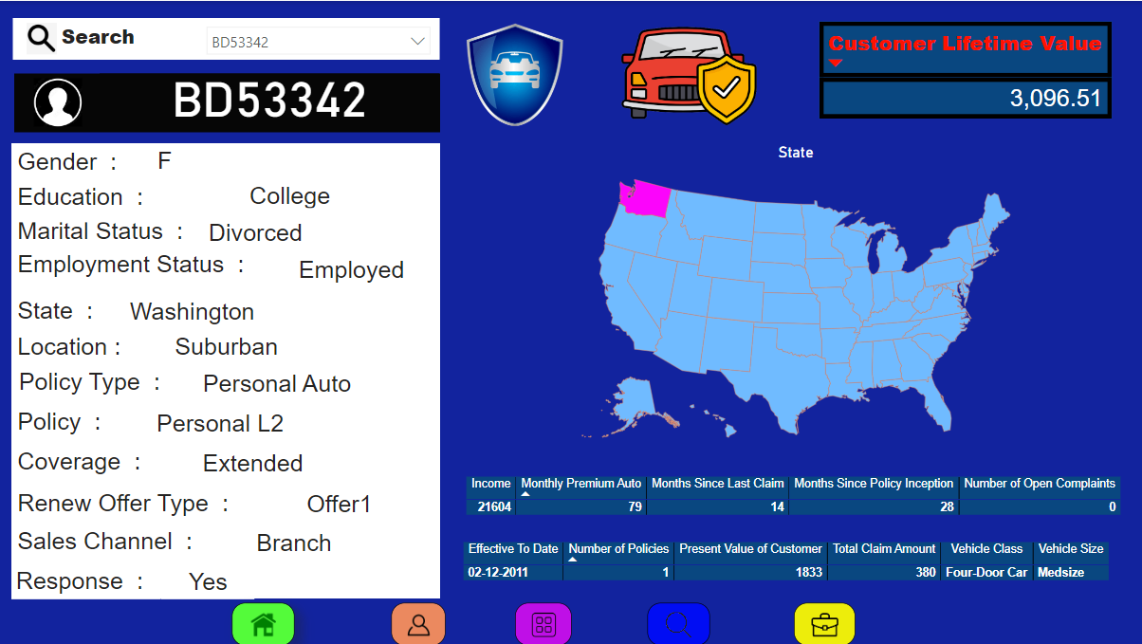

This is our final dashboard of Customer Lifetime Value project.

**7**

**2.7 Power BI service**

* Power BI is a collection of software services, apps, and connectors that work together to help you create, share, and consume business insights in the way that serves you and your business most effectively.
* The Microsoft Power BI service (https://app.powerbi.com), sometimes referred to as Power BI online, is the software as a service (SaaS) part of Power BI.
* In the Power BI service, dashboards help you keep a finger on the pulse of your business. Dashboards display tiles, which you can select to open reports for exploring further. Dashboards and reports connect to datasets that bring all of the relevant data together in one place.

# **1) Creating reports in the service**

In a typical Power BI workflow, you begin by building a report in Power BI Desktop, then publishing it to the Power BI service.

* This workflow is common, but you can also create Power BI reports right in the Power BI service. Do you have a subscription to a SaaS application like Salesforce?
* Power BI has apps that automatically create dashboards and reports from your online data. Get a head start by connecting to Salesforce or [check out the other SaaS apps](https://learn.microsoft.com/en-us/power-bi/connect-data/service-get-data) you can connect to.
* If you're part of an organization, someone in your organization might have published [apps](https://learn.microsoft.com/en-us/power-bi/collaborate-share/service-create-distribute-apps) and distributed them to you.

# **2) Sharing your findings**

# After you've created reports and dashboards, you can share them. End users in the Power BI service and mobile devices can view and interact with them. Being able to control how you share your work is one of the most important features of the Power BI service. You create workspaces where you and your colleagues can collaborate on reports and dashboards. Then you can bundle and distribute them as apps. You can also share the datasets themselves, so others can use them as a basis for their own reports. Read more about [ways to collaborate and share your work in Power BI.](https://learn.microsoft.com/en-us/power-bi/collaborate-share/service-how-to-collaborate-distribute-dashboards-reports)

**3. Deploypment:**

**Publish a report or Dashboard:**

Distribute and access insights anywhere by combining Power BI Desktop and Power BI Pro. Collaborate and build report with colleagues and then public and share those reports anytime, anywhere and on any device.

After creating a report with a few visuals, you're ready to publish to the Power BI service.

**Step 1) Login to the Power BI NovyPro service account:**

* Login Power BI service with Novypro developer account.
* After successfully login online Power BI we Create new workspace for over project.
* eg **Project Workspace,** here we upload over dashboard for publishing.

**8**

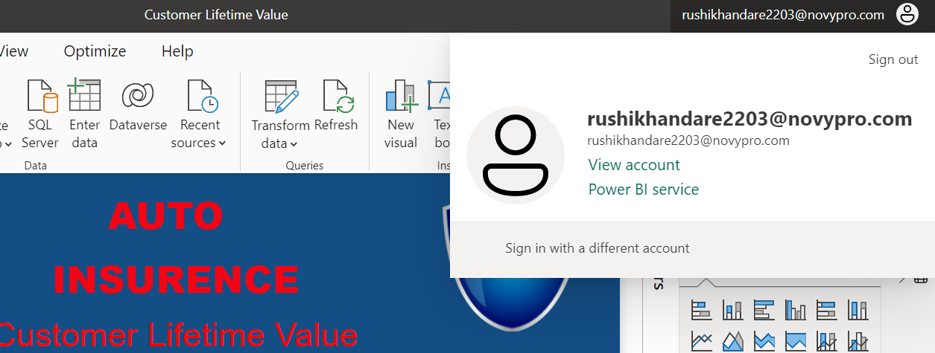

**Step 2) Publish dashboard on power BI service:**

* On the Home ribbon on the Power BI Desktop, select Publish.
* Upload over current dashboard into created workspace.

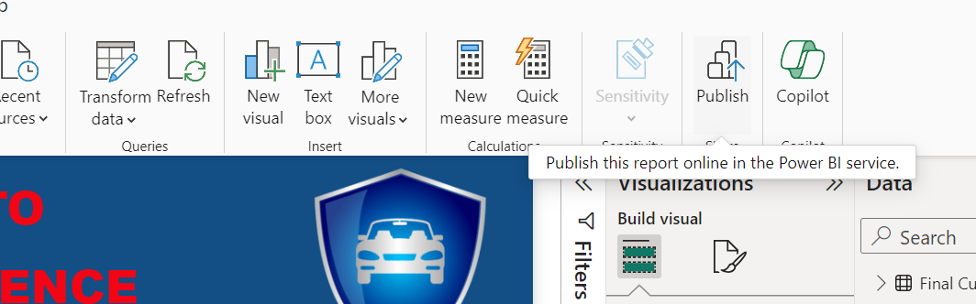

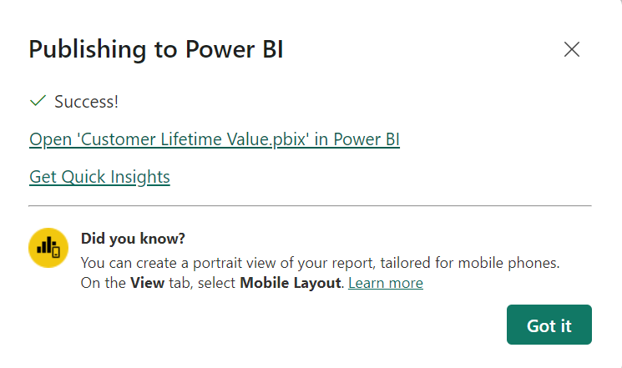

**9**

* After uploading its popup dialog box with success!.
* You can select the link below Success!, which will take you to the Power BI service, where you can see the report that you publish.
* After Successfully publishing dashboard on workspace share it as a embedded web.
* It is generate link copy this link and past NovyPro profile at the time of report publishing.

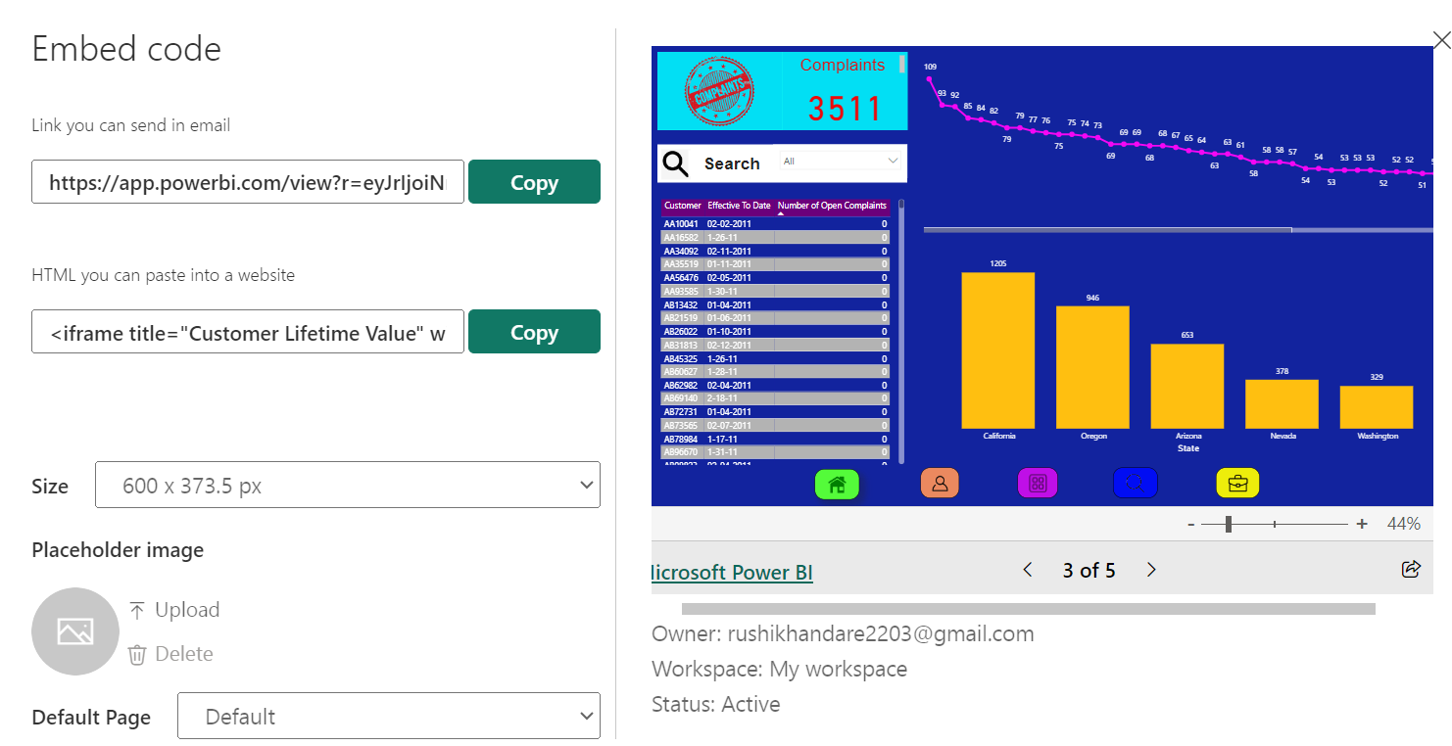

**Step 3) Publish dashboard with NovyPro:**

* Login into NovyPro account with email id and password.
* Activate email id and Power BI account for portfolio.
* Click on report “+” for add and publish new report or dashboard.
* Given is the final dashboard we publishing on NovyPro.
* That is available for all viewers.

